Cancer Researchers Put Hope In Stem Cells
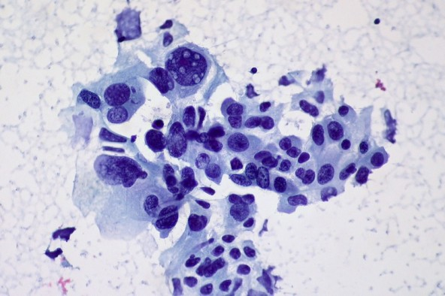

All this week researchers from across the world gathered in Cleveland to attend Case Western Reserve University’s Cancer Stem Cell conference.
For several years now, researchers have been kicking around a theory to explain how cancer operates in the body. They think tumors are spurred on by a certain group of cells known as “cancer stem cells.”
Dr. Stan Gerson heads up the Case Comprehensive Cancer Center and the National Center for Regenerative Medicine. He says these cancer stem cells are the guys at the wheel.
“These are the drivers. They’re the fundamental reason that we can’t cure cancer today and why new treatments that are designed to first get rid of the bulk of the tumor and then immediately come back and go after the cancer stem cell are so important,” he said.
The idea here is that to really cure a body of cancer, you have to nip it at the root, or else the cancer will just crop right back up. Kind of like a weed—you can mow it down, but if you don’t get the roots, it’ll spring back up.
Gerson says we’re closing in on new therapies that target these cancer stem cells; he expects them to hit the market in 3-5 years.

